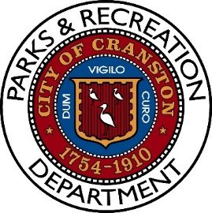
Notice of Meeting
Parks and Recreation Advisory Board Meeting
Tuesday, June 24th, 2025, 6:00PM
Pastore Youth Center
155 Gansett Avenue
Cranston, RI 02910

AGENDA

- Roll Call

- Spring Season Review

- Equipment Update

- Update on Ongoing Projects

  - Playground mulching/repairs/upgraded drainage/fencing
  - Dutemple Basketball Court
  - Doric Spalsh Pad and Basketball Court
  - Garden City PIP
  - Garbage barrel replacement
  - Developing a department identity
  - Preventative maintenance schedule
  - Privatize of some services

- Indoor Recreation
  - Needs
  - Community Input
  - Possible Locations

- Concerns about daily illegal garbage, What can be done?

- Fall Projects

- Open Dialogue

- Adjourn

